E-Safety Agreement September 2024
At school we use the computers, iPads and the internet to help everybody with their learning. We follow the rules below to keep everyone safe.
- Follow the SMART rules
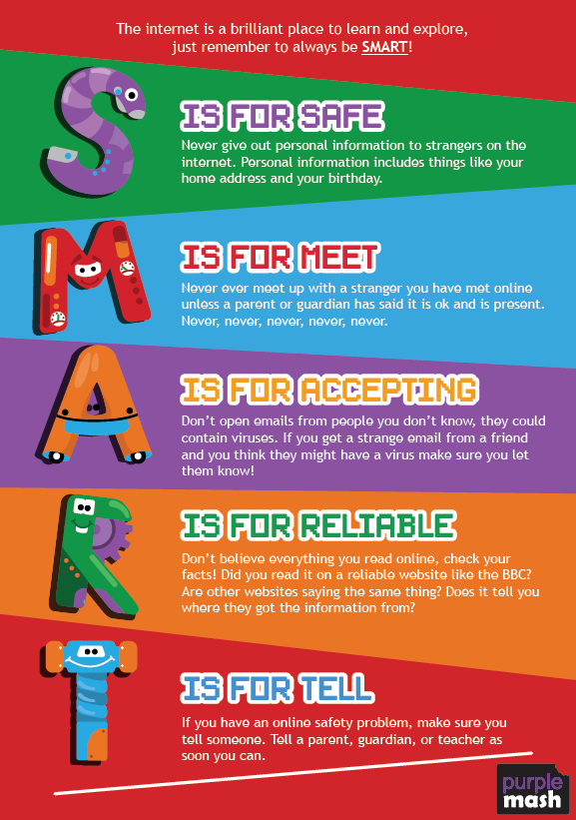
- Keep your personal information private
- Think about what you say and do online and treat people with respect
- Tell a trusted adult if you are worried about anything online
- Ask an adult if you can use a computer or an iPad if you are not in a computing lesson
- Only use the programmes that are appropriate for the lesson
- Ask permission before entering any website unless your teacher has already said you can use it
- Do not open unknown links and attachments
- Do not edit other children’s files in Purple Mash
If you do not follow these rules then you could be stopped from using the internet, computers or iPads.

September 2024

